Gillian Keegan MP
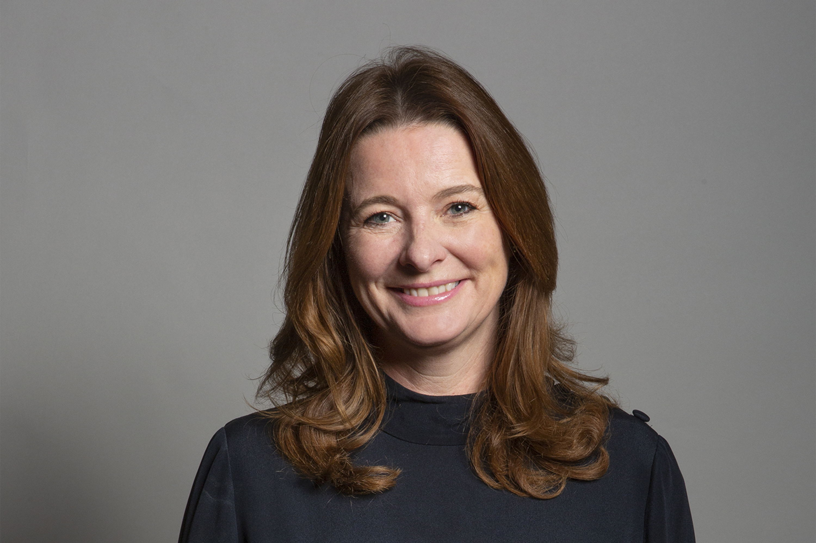
Biography
Gillian Keegan was appointed Minister of State for Care at the Department of Health and Social Care on 16 September 2021.

Minister of State (Minister for Care and Mental Health)

The Minister of State for Care and Mental Health leads on the following:
- adult social care
- health and care integration
- dementia, disabilities and long-term conditions
- NHS Continuing Healthcare
- mental health
- suicide prevention and crisis prevention
- offender health
- vulnerable groups
- bereavement

